Grade 3
Pack the Crate

Description: | Students will:  Plan a game with two moving objects.  Make a script to control simultaneous motion on the x and y axis. Construct new commands from two objects’ script tiles.  Experiment with script tiles for x/y increase and/or decrease.  Make reset scripts to position objects at specific locations.  Type or draw a “You Win” message.  Create a script that displays the win message appropriately.
Project View | 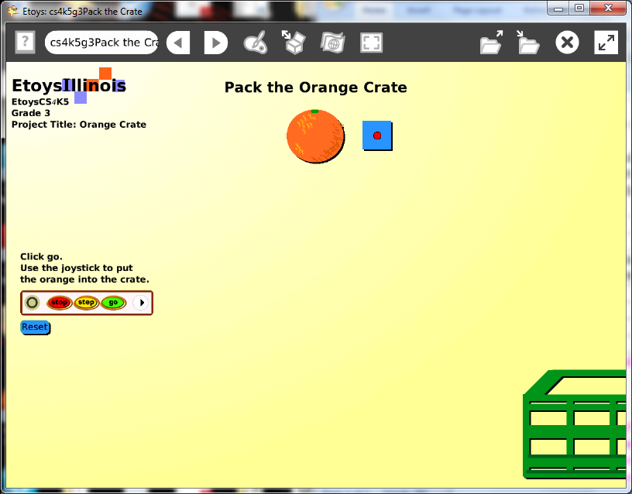
Subject: | Mathematics
Etoys Quick Guides | Click the question mark in Etoys to open the set of interactive tutorials for basic tools and techniques.
Vocabulary: | X and y axis, locations, x increase by, x decrease by, y increase by, y decrease by, conditional statements, < , >
Lesson 1:  Paint Tools: Brushes  Supplies: Joystick Control | Discuss ideas for projects that have two moving objects and where they will meet. Examples: an orange in a box, sprinkles on a cupcake, hat on a head, nose on a face, spaceship on a moon.  Paint one of the objects that will move and keep it. Open a new paint palette, draw the other object that will move and keep it. This project’s two objects are a box that moves right to left like it is on a conveyor belt and an orange that moves down.  Start with the object that will be controlled with a joystick.  The Orange’s script: this script uses a joystick from Supplies to control direction on the x and the y axis.  Give students time to experiment with combinations of these commands.  Discuss: x and y, increase and decrease, and left right and up down. Give students more time to experiment.  Ask what if: orange’s x decreased by joystick’s up down?  Ask students to decide what combination of these pairs of options will work best in their project.  Make the script and give it a meaningful name. This project has four scripts so naming each object and each script is important and will prevent some confusion.  Keep the project: Namejoy e.g. KateJoy
Lesson 2:  Script Tiles: X and Y Locations | The Box’s script:  Discuss the direction of motion for the second object. This box moves across the screen like on a conveyor belt.  Give students time to experiment with how far off the screen and how long it will be before it appears in the new location. Distance and time and related. It is also interesting for students to look at the x and y location information in the Viewer while the script is ticking and to realize they know where something is, even when they cannot see it.  Keep the project.
Lesson 3:  Script Tiles: Hide and Show  Menus: Button to Fire a Script  Supplies: Add a Flap | You Win Script, Reset Button, Title, rules flap  Type or draw a message that will show when the two objects touch. Open a Viewer for the text use hide and show tiles.  Make a Reset script that will locate both objects at their starting position and returns them there when the script is called. Name the script.  Use the white menu in the Scriptor to make a button to fire this script.  The button’s text can be changed by opening its white menu and choosing the option: change label. The button’s color can be changed using its repaint tool.  Give students time to experiment with these menu options. They take time to understand and then to decide which of the available options to use and what to specify. The more of these options are applied the more customized projects will be.  Students can include information about how to use the joystick and the goal of the game. It can be on the screen or in a flap.  Keep the project.  Give students time to enjoy their project and to try ones made by others in the class. They build a wealth of knowledge during these experiments that can be discussed and applied.  Discuss ideas they have after seeing other projects. Give them time to modify their project again.  Keep the project.
Standards: | Common Core Standards  Mathematics: 3.MD.3.4  Bloom’s Taxonomy/Cognitive Domain:  Knowledge: knows  Application: uses, constructs, changes, discovers  Analysis: analyzes, compares, experiments  Evaluation: reviews  NETS  1. a, b, c  2. a  4. a, b
Resources: | Etoys Help Quick Guides: always available in Etoys. Open Etoys and click the question mark to open a set of interactive tutorials of basic tools and techniques.  www.etoysillinois.org projects, lesson plans, software download  www.mste.Illinois.org more math, science, and technology resources  www.corestandards.org Common Core Standards  www.squeakland.org software and Etoys projects  www.nctm.org Standards and Focal Points for each grade level
kh January 2011

